1. **Short sale constraint** – We are not allowed to take a short position in any ETF i.e., the minimum allowed weight for any ETF is zero and cannot go below that

**weight of ETFi >= 0**

1. **Budget constraint** -Budget constraint are constraints that confine the sum of portfolio weights to fall either above or below specific bounds

**lower bound (LB) < Σ(weight of portfolio) <= Upper bound (UB)**

This constraint is specifying how much money must be in the form of cash

For example, Budget constraint is specifying UB = LB = 100%

That means the invested amount should be in the form of stocks, bonds and other asset classes and 0% allocation to cash

*Additional documents to read* - https://www.mathworks.com/help/finance/portfolio-set-for-optimization-using-portfolio-object.html#bswwesk-4

1. **Stock Ratio constraint** – Stock ratio constraint allows the weights of the stocks & bond ETFs to vary among themselves I.e., they do not have to have the same weights necessarily

In simpler terms, assets do not have to be equally weighted. Given below is an example of the same :

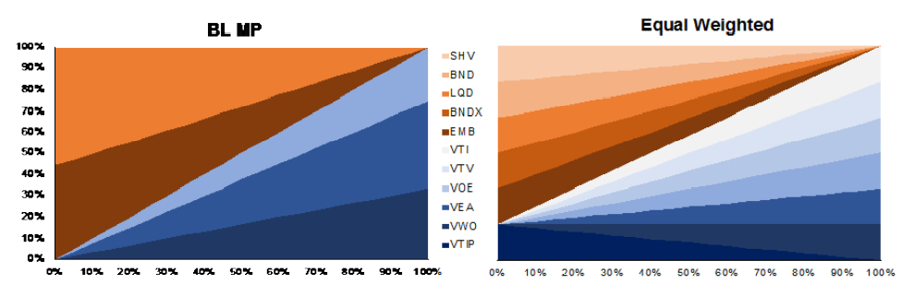

1. **Maximum Weight constraint -**  What percentage of stock ETFs can be included in the portfolio?

Sum of weights of all stock ETFs have to be a certain percentage

Say for example, we have 6 stock ETFs and we want the sum of the six stock ETFs to not be greater than 40%

**Σ(weight of ETF1,weight of ETF2,weight of ETF3,weight of ETF4,weight of ETF5,weight of ETF6) <= 40**

**SHV and VTIP Dynamic Weight Constraint –** Restrict the optimizer to use only the weights of VTIP and SHV that Betterment assigns

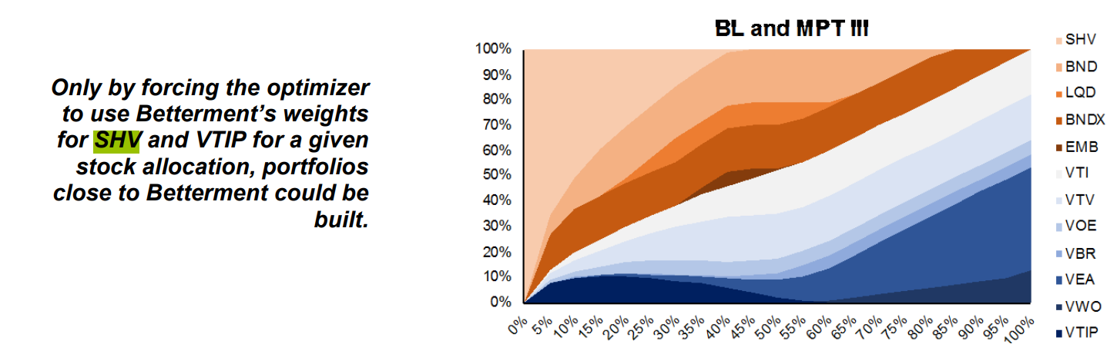

**Why SHV and VTIP?**

SHV is cash ETF.

Black Litterman model gave negative returns for VTIP